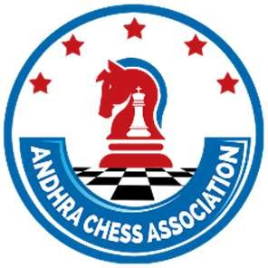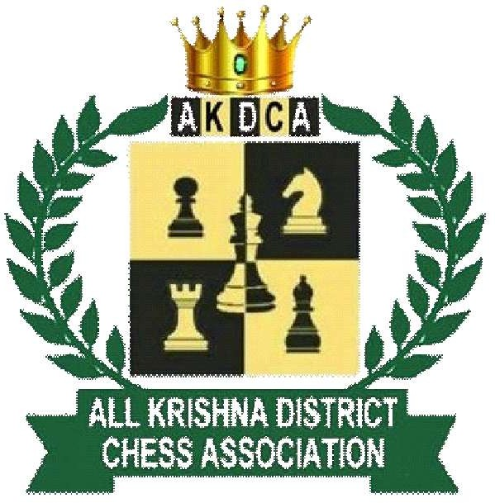

Rule and Regulations For Participating in “KRISHNA DISTRICT OFFICIAL CHESS TOURNAMRENTS”

- REGISTRATION THROUGH apchess.org only

- No Spot Entries Entertained

- Without Participating in District Selections a Player is not entertained to participate in State level championship

- Academy T-Shirts are not allowed into the Tournament Hall.

- In KRISHNA DISTRICT SELECTION TOURNAMENTS, If there are Minimum 5 Players there will be TOP-1 Prize in each age group (boys and girls) separate and if there are 10 or more players in age group then TOP-2 Prizes will be given (boys and girls)
Kindly Cooperate With the Management Thank You
M V L N DIVYA
Secretary
KRISHNA District Chess Association

